Software Engineering | Introduction to Software Engineering

Software is a program or set of programs containing instructions that provide desired functionality. And Engineering is the process of designing and building something that serves a particular purpose and finds a cost-effective solution to problems.
Software Engineering is the process of designing, developing, testing, and maintaining software. It is a systematic and disciplined approach to software development that aims to create high-quality, reliable, and maintainable software. Software engineering includes a variety of techniques, tools, and methodologies, including requirements analysis, design, testing, and maintenance.

What is Software Engineering?
The term software engineering is the product of two words, software, and engineering.
The software is a collection of integrated programs.
Software subsists of carefully-organized instructions and code written by developers on any of various particular computer languages.
Computer programs and related documentation such as requirements, design models and user manuals.
Engineering is the application of scientific and practical knowledge to invent, design, build, maintain, and improve frameworks, processes, etc.
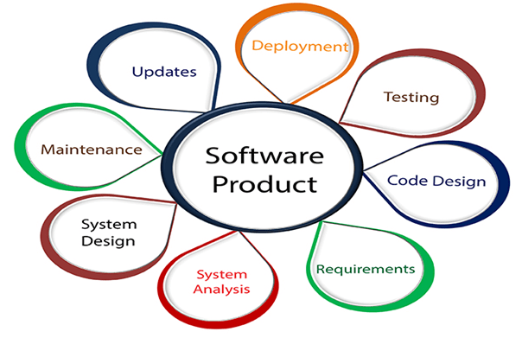
Software Engineering is an engineering branch related to the evolution of software product using well-defined scientific principles, techniques, and procedures. The result of software engineering is an effective and reliable software product.

Why is Software Engineering required?
Software Engineering is required due to the following reasons:
- To manage Large software
- For more Scalability
- Cost Management
- To manage the dynamic nature of software
- For better quality Management

Need of Software Engineering
The necessity of software engineering appears because of a higher rate of progress in user requirements and the environment on which the program is working.
- Huge Programming: It is simpler to manufacture a wall than to a house or building, similarly, as the measure of programming become extensive engineering has to step to give it a scientific process.
- Adaptability: If the software procedure were not based on scientific and engineering ideas, it would be simpler to re-create new software than to scale an existing one.
- Cost: As the hardware industry has demonstrated its skills and huge manufacturing has let down the cost of computer and electronic hardware. But the cost of programming remains high if the proper process is not adapted.
- Dynamic Nature: The continually growing and adapting nature of programming hugely depends upon the environment in which the client works. If the quality of the software is continually changing, new upgrades need to be done in the existing one.
- Quality Management: Better procedure of software development provides a better and quality software product.

Characteristics of a good software engineer
The features that good software engineers should possess are as follows:
Exposure to systematic methods, i.e., familiarity with software engineering principles.
Good technical knowledge of the project range (Domain knowledge).
Good programming abilities.
Good communication skills. These skills comprise of oral, written, and interpersonal skills.
High motivation.
Sound knowledge of fundamentals of computer science.
Intelligence.
Ability to work in a team
Discipline, etc.

Importance of Software Engineering
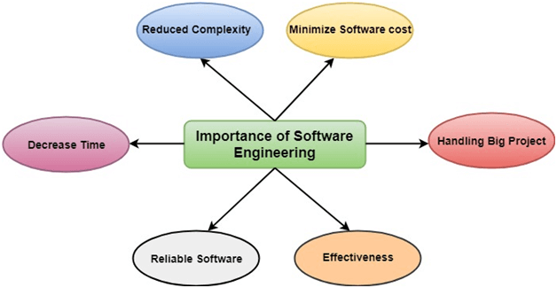
The importance of Software engineering is as follows:
- Reduces complexity: Big software is always complicated and challenging to progress. Software engineering has a great solution to reduce the complication of any project. Software engineering divides big problems into various small issues. And then start solving each small issue one by one. All these small problems are solved independently to each other.
- To minimize software cost: Software needs a lot of hardwork and software engineers are highly paid experts. A lot of manpower is required to develop software with a large number of codes. But in software engineering, programmers project everything and decrease all those things that are not needed. In turn, the cost for software productions becomes less as compared to any software that does not use software engineering method.
- To decrease time: Anything that is not made according to the project always wastes time. And if you are making great software, then you may need to run many codes to get the definitive running code. This is a very time-consuming procedure, and if it is not well handled, then this can take a lot of time. So if you are making your software according to the software engineering method, then it will decrease a lot of time.
- Handling big projects: Big projects are not done in a couple of days, and they need lots of patience, planning, and management. And to invest six and seven months of any company, it requires heaps of planning, direction, testing, and maintenance. No one can say that he has given four months of a company to the task, and the project is still in its first stage. Because the company has provided many resources to the plan and it should be completed. So to handle a big project without any problem, the company has to go for a software engineering method.
- Reliable software: Software should be secure, means if you have delivered the software, then it should work for at least its given time or subscription. And if any bugs come in the software, the company is responsible for solving all these bugs. Because in software engineering, testing and maintenance are given, so there is no worry of its reliability.
- Effectiveness: Effectiveness comes if anything has made according to the standards. Software standards are the big target of companies to make it more effective. So Software becomes more effective in the act with the help of software engineering.

Key Principles of Software Engineering
- Modularity: Breaking the software into smaller, reusable components that can be developed and tested independently.
- Abstraction: Hiding the implementation details of a component and exposing only the necessary functionality to other parts of the software.
- Encapsulation: Wrapping up the data and functions of an object into a single unit, and protecting the internal state of an object from external modifications.
- Reusability: Creating components that can be used in multiple projects, which can save time and resources.
- Maintenance: Regularly updating and improving the software to fix bugs, add new features, and address security vulnerabilities.
- Testing: Verifying that the software meets its requirements and is free of bugs.
- Design Patterns: Solving recurring problems in software design by providing templates for solving them.
- Agile methodologies: Using iterative and incremental development processes that focus on customer satisfaction, rapid delivery, and flexibility.
- Continuous Integration & Deployment: Continuously integrating the code changes and deploying them into the production environment.

Software engineering is a rapidly evolving field, and new tools and technologies are constantly being developed to improve the software development process. By following the principles of software engineering and using the appropriate tools and methodologies, software developers can create high-quality, reliable, and maintainable software that meets the needs of its users.
Software Engineering is mainly used for large projects based on software systems rather than single programs or applications. The main goal of Software Engineering is to develop software applications for improving quality, budget, and time efficiency. Software Engineering ensures that the software that has to be built should be consistent, correct, also on budget, on time, and within the required requirements.

Main Attributes of Software Engineering
Software Engineering is a systematic, disciplined, quantifiable study and approach to the design, development, operation, and maintenance of a software system. There are Four main Attributes of Software Engineering.
- Efficiency
- Reliability
- Robustness
- Maintainability

Dual Role of Software
There is a dual role of software in the industry. The first one is as a product and the other one is as a vehicle for delivering the product. We will discuss both of them.

1. As a product
- It delivers computing potential across networks of Hardware.
- It enables the Hardware to deliver the expected functionality.
- It acts as an information transformer because it produces, manages, acquires, modifies, displays, or transmits information.

2. As a vehicle for delivering a product
- It provides system functionality (e.g., payroll system)
- It controls other software (e.g., an operating system)
- It helps build other software (e.g., software tools)

Objectives of Software Engineering
- Maintainability: It should be feasible for the software to evolve to meet changing requirements.
- Efficiency: The software should not make wasteful use of computing devices such as memory, processor cycles, etc.
- Correctness: A software product is correct if the different requirements specified in the SRS Document have been correctly implemented.
- Reusability: A software product has good reusability if the different modules of the product can easily be reused to develop new products.
- Testability: Here software facilitates both the establishment of test criteria and the evaluation of the software with respect to those criteria.
- Reliability: It is an attribute of software quality. The extent to which a program can be expected to perform its desired function, over an arbitrary time period.
- Portability: In this case, the software can be transferred from one computer system or environment to another.
- Adaptability: In this case, the software allows differing system constraints and the user needs to be satisfied by making changes to the software.
- Interoperability: Capability of 2 or more functional units to process data cooperatively.

Program vs Software Product
Program | Software Product
A program is a set of instructions that are given to a computer in order to achieve a specific task. | Software is when a program is made available for commercial business and is properly documented along with its licensing.  Software Product = Program + Documentation + Licensing.
Program is one of the stages involved in the development of the software. | Software Development usually follows a life cycle, which involves the feasibility study of the project, requirement gathering, development of a prototype, system design, coding, and testing.

Advantages of Software Engineering
There are several advantages to using a systematic and disciplined approach to software development, such as:
- Improved Quality: By following established software engineering principles and techniques, the software can be developed with fewer bugs and higher reliability.
- Increased Productivity: Using modern tools and methodologies can streamline the development process, allowing developers to be more productive and complete projects faster.
- Better Maintainability: Software that is designed and developed using sound software engineering practices is easier to maintain and update over time.
- Reduced Costs: By identifying and addressing potential problems early in the development process, software engineering can help to reduce the cost of fixing bugs and adding new features later on.
- Increased Customer Satisfaction: By involving customers in the development process and developing software that meets their needs, software engineering can help to increase customer satisfaction.
- Better Team Collaboration: By using Agile methodologies and continuous integration, software engineering allows for better collaboration among development teams.
- Better Scalability: By designing software with scalability in mind, software engineering can help to ensure that software can handle an increasing number of users and transactions.
- Better Security: By following the Software Development Life Cycle (SDLC) and performing security testing, software engineering can help to prevent security breaches and protect sensitive data.
In summary, software engineering offers a structured and efficient approach to software development, which can lead to higher-quality software that is easier to maintain and adapt to changing requirements. This can help to improve customer satisfaction and reduce costs, while also promoting better collaboration among development teams.

Disadvantages of Software Engineering
While Software Engineering offers many advantages, there are also some potential disadvantages to consider:
- High upfront costs: Implementing a systematic and disciplined approach to software development can be resource-intensive and require a significant investment in tools and training.
- Limited flexibility: Following established software engineering principles and methodologies can be rigid and may limit the ability to quickly adapt to changing requirements.
- Bureaucratic: Software Engineering can create an environment that is bureaucratic, with a lot of processes and paperwork, which may slow down the development process.
- Complexity: With the increase in the number of tools and methodologies, software engineering can be complex and difficult to navigate.
- Limited creativity: The focus on structure and process can stifle creativity and innovation among developers.
- High learning curve: The development process can be complex, and it requires a lot of learning and training, which can be challenging for new developers.
- High dependence on tools: Software engineering heavily depends on the tools, and if the tools are not properly configured or are not compatible with the software, it can cause issues.
- High maintenance: The software engineering process requires regular maintenance to ensure that the software is running efficiently, which can be costly and time-consuming.
In summary, software engineering can be expensive and time-consuming, and it may limit flexibility and creativity. However, the benefits of improved quality, increased productivity, and better maintainability can outweigh the costs and complexity. It’s important to weigh the pros and cons of using software engineering and determine if it is the right approach for a particular software project.

Questions For Practice
1. A software configuration management tool helps in [GATE CS 2004]
(A) keeping track of the schedule based on the milestone reached
(B) maintaining different versions of the configurable items
(C) managing manpower distribution by changing the project structure
(D) all of the above
Solution: Correct Answer is (B).

2. Which of the following statements is/are true? [UGC NET CSE 2018]
P: Software Reengineering is preferable for software products having high failure rates,
poor design, and/or poor code structure.
Q: Software Reverse Engineering is the process of analyzing software with the objective of
recovering its design and requirement specification.
(A) P only
(B) Neither P nor Q
(C) Q only
(D) Both P and Q
Solution: Correct Answer is (D).

3. The diagram that helps in understanding and representing user requirements for a software project using UML (Unified Modeling Language) is:

[GATE CS 2004]
(A) Entity Relationship Diagram
(B) Deployment Diagram
(C) Data Flow Diagram
(D) Use Case Diagram
Solution: Correct Answer is (D).

